**CSC 3020 – Java Programming**

**Homework 2 – [Sayem Chowdhury]**

**25 points – Due February 7, 10am**

**Late deadline is February 9, 11:59pm, but 20% off**

**a)** Save this document with your name and the homework number somewhere in the file name.

**b)** Type/paste your answers into the document.

**c)** Submit this document and your .java file(s) to the Blackboard item where you downloaded this document. Do not submit a zip file but individually attach your files.

**1) [8 points]** Write regular expressions after the ► to validate the following strings:

**a)** An International Standard Book Number (ISBN). This is a unique 13-digit number assigned to each edition of a book. An ISBN contains hyphens. Here is a sample: 978-3-16-148410-0. Assume that each digit is in the range 0-9.

► "[0-9]\\d{2}-[0-9]-[0-9]\\d{1}-[0-9]\\d{5}-[0-9]"

**b)** A one- or two-character chemical symbol of an element from the Periodic Table.

► "([A-Z]|[A-Z][a-z])"

**c)** A measurement including a whole number and units separated by one space. A sample measurement is 34 oz. Assume that units is lower case letters only.

► "[0-9]+ [a-z]+"

**d)** A two-character abbreviation for any of the eight US states or the Canadian province adjacent to the Great Lakes. Assume the abbreviation is upper case characters only.

► "(MI|FL|NY|TX|NJ|AL|HI|IL)"

Comments: I also Add my Screen Shot below of the Problem (1)

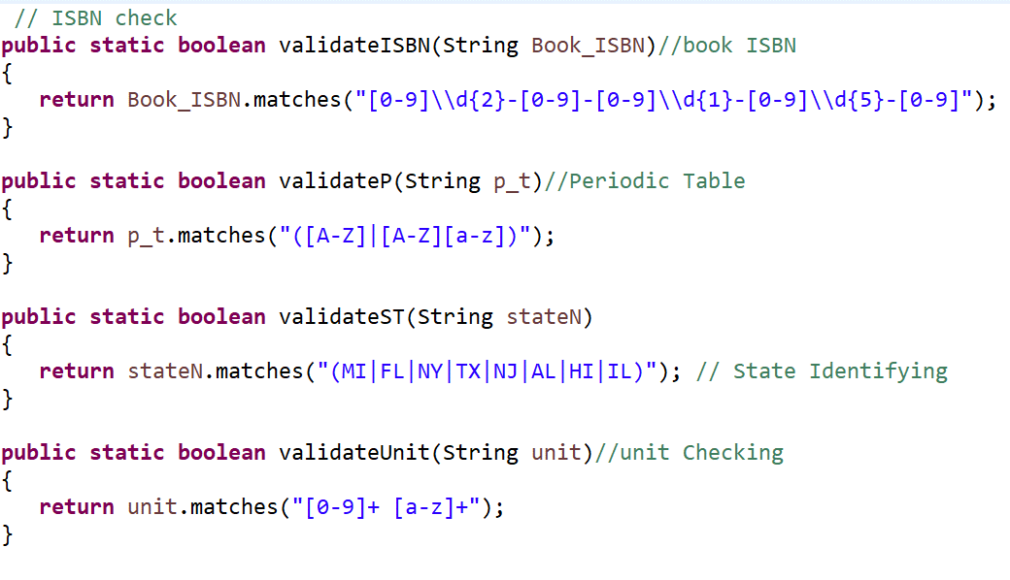

**2) [9 points]** You've been hired by *Money Monarchs* to write a Java console application that converts between currencies US Dollar ($), Euro (€), and Japanese Yen (¥). Prompt the user for a conversion code:

| Code | Conversion | Last run input |
| --- | --- | --- |
| a | US Dollar → Euro | 32 |
| b | US Dollar → Japanese Yen | 64 |
| c | Euro → US Dollar | 200 |
| d | Euro → Japanese Yen | 300 |
| e | Japanese Yen → US Dollar | 24 |
| f | Japanese Yen → Euro | 28 |
| x | Exit |  |

JY

Then prompt and get from the user a currency value. Convert the currency value and show the two values, rounded to two decimal places, with appropriate units. Continue to prompt the user for conversion codes until the sentinel value of ‘x’. Research the current conversion rates, and represent and use them as double constants. Locate the UNICODE values for units € and ¥, and represent and use them as string constants. They will be in the form "\uHHHH". Use the inputs shown in the table for the last six inputs.

*[your program code here*

*//======================================================================*

*// Title: <Currency_conversion>*

*// Course: CSC 3020*

*// Homework: <2>*

*// Author: <Sayem Chowdhury>*

*// Date: <02/06/2018>*

*// Description:*

*/*<The Java console application that converts between currencies US Dollar ($), Euro (€), and Japanese Yen (¥).*

*\* and Prompt the user to choose a conversion code until choosing exit option.>*

*\*/*

*//*

*//======================================================================*

*//Package name*

*package Money_M;*

*// Import Classes*

*import java.util.Scanner;*

*//main class*

*public class Currency_conversion {*

*//main function*

*public static void main(String[] args) {*

*// Constant variables for currency symbol*

*final String USD="\u0024";*

*final String JYEN="\u00A5";*

*final String EURO="\u20AC";*

*//Show application Header*

*System.out.println("Welcome to Currency Conversion");*

*System.out.println("---------------------------------------\n");*

*// Display Conversion Rate*

*System.out.println("Code\t\t Conversion");*

*System.out.println("----------------------------------------");*

*System.out.println(" a\t\t US Dollar-> Euro ");*

*System.out.println(" b\t\t US Dollar-> Japanese Yen ");*

*System.out.println(" c\t\t Euro-> US Dollar ");*

*System.out.println(" d\t\t Euro-> Japanese Yen ");*

*System.out.println(" e\t\t Japanese Yen-> US Dollar ");*

*System.out.println(" f\t\t Japanese Yen-> Euro ");*

*System.out.println(" x\t\t Exit ");*

*System.out.println("----------------------------------------\n");*

*//constant Variables for money conversion Rate*

*final double D2E=0.81;*

*final double D2JY=109.42;*

*final double E2UD=1.23;*

*final double E2JY=135.11;*

*final double JY2UD=0.0091;*

*final double JY2E=0.0074;*

*// Creating Input Object*

*Scanner kbd= new Scanner (System.in);*

*//loop that prompt for code conversion until choose exit option*

*while(true)*

*{*

*System.out.print("Please enter the code for currency conversion:\n ");*

*String In=kbd.next();*

*//variables for user input and saving calculation*

*double M=0.0;*

*double CM;*

*if (In.equals("a")) // conversion of Dollar to Euro*

*{*

*System.out.println("Please enter the curreny value in US Dollar:");*

*M=kbd.nextDouble();*

*CM=M*D2E;*

*System.out.printf("%2.2f%s%2.2f%s",M, USD+"=", CM, EURO);*

*System.out.println("\n");*

*}*

*else if(In.equals("b"))//conversion of Dollar to YEN*

*{*

*System.out.println("Please enter the curreny value in US Dollar:");*

*M=kbd.nextDouble();*

*CM=M*D2JY;*

*System.out.printf("%2.2f%s%2.2f%s",M, USD+" =", CM, JYEN );*

*System.out.println("\n");*

*}*

*else if(In.equals("c"))//Conversion of Euro to Dollar*

*{*

*System.out.println("Please enter the curreny value in Euro:");*

*M=kbd.nextDouble();*

*CM=M*E2UD;*

*System.out.printf("%2.2f%s%2.2f%s",M, EURO+" =", CM, USD);*

*System.out.println("\n");*

*}*

*else if(In.equals("d"))//Conversion of Euro Japanese YEN*

*{*

*System.out.println("Please enter the curreny value in Euro:");*

*M=kbd.nextDouble();*

*CM=M*E2JY;*

*System.out.printf("%2.2f%s%2.2f%s",M, EURO+"=", CM, JYEN);*

*System.out.println("\n");*

*}*

*else if(In.equals("e"))//Conversion of Japanese YEN to Dollar*

*{*

*System.out.println("Please enter the curreny value in Japanese Yen:");*

*M=kbd.nextDouble();*

*CM=M*JY2UD;*

*System.out.printf("%2.2f%s%2.2f%s",M, JYEN+"=", CM, USD);*

*System.out.println("\n");*

*}*

*else if(In.equals("f"))// Conversion of Japanese YEN to Euro*

*{*

*System.out.println("Please enter the curreny value in Japanese Yen:");*

*M=kbd.nextDouble();*

*CM=M*JY2E;*

*System.out.printf("%2.2f%s%2.2f%s",M, JYEN+"=", CM, EURO );*

*System.out.println("\n");*

*}*

*else if(In.equals("x"))// Exit option from the Application*

*{*

*//End of Application*

*System.out.println("End of Currency Conversion");*

*//close kbd*

*kbd.close();*

*System.exit(0);*

*}*

*else // If user input wrong code prompt the message*

*{*

*System.out.println("You chooses wrong code");*

*}*

*}*

*}*

*}*

*]\**

**If possible, format your code like this:**

**Font “Courier New”**

**Font size “9”**

**Bold**

*[your program output here*

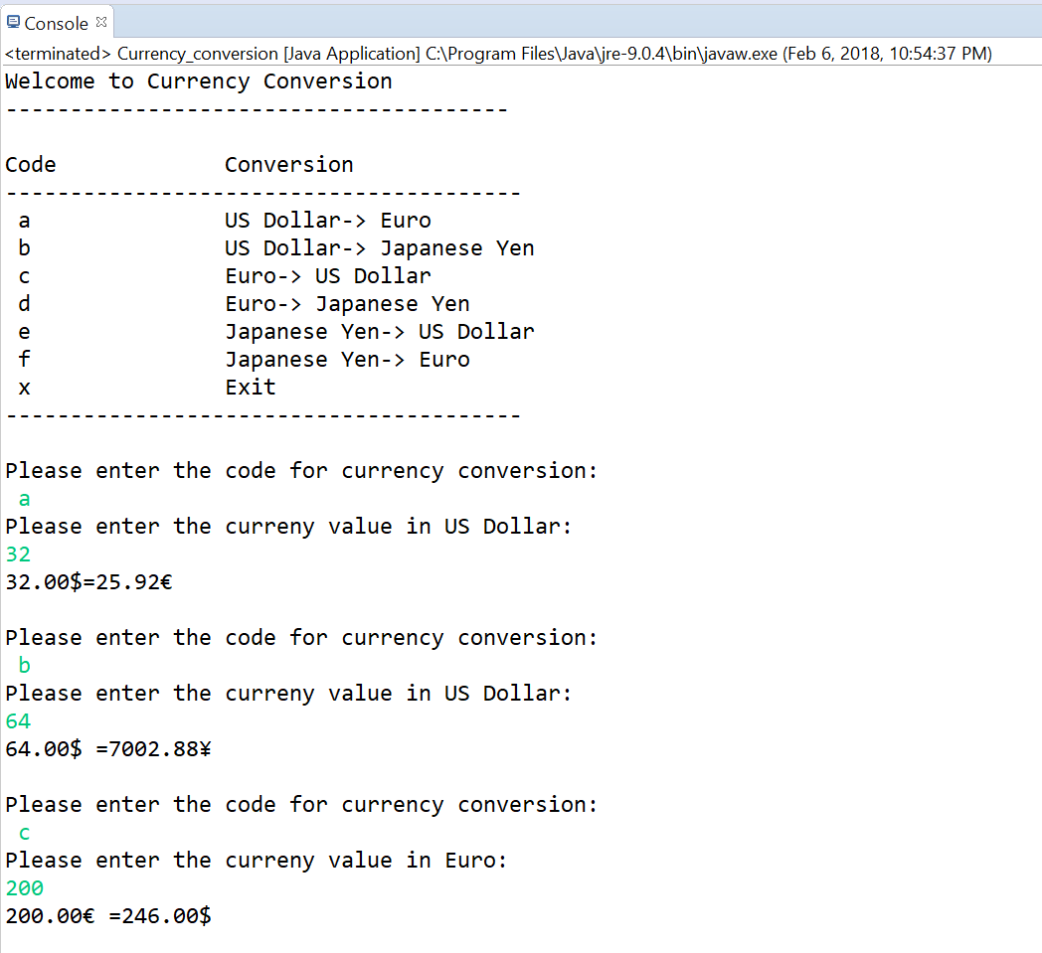

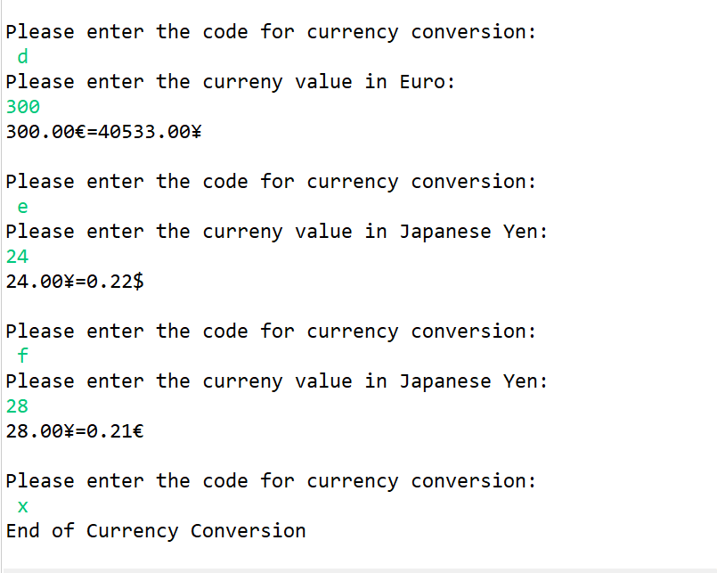

*]\*\**

**3) [8 points]** You've been hired by *Readability Ravens* to write a Java console application that analyzes a paragraph for readability using the Coleman–Liau index. Prompt the user for a paragraph, and then calculate and show the following:

● Number of characters.

● Number of whitespace characters.

● Number of non-whitespace characters.

● Number of sentences – these are delimited by periods (.).

● Number of words – these are delimited by one or more spaces, commas, and periods.

● Number of word letters.

● Coleman–Liau index – this is calculated as follows:

1) Count the number of sentences.

2) Count the number of words.

3) Count the number of letters in words.

4) Calculate L = Letters ÷ Words × 100.

5) Calculate S = Sentences ÷ Words × 100.

6) Calculate CLI = 0.0588L - 0.296S - 15.8.

Format the output in two columns with the first column containing a label and the second column containing a value. Format the CLI to two decimal places. To test your program, use paragraph:

Existing computer programs that measure readability are based largely upon subroutines which estimate number of syllables, usually by counting vowels. The shortcoming in estimating syllables is that it necessitates keypunching the prose into the computer. There is no need to estimate syllables since word length in letters is a better predictor of readability than word length in syllables. Therefore, a new readability formula was computed that has for its predictors letters per 100 words and sentences per 100 words. Both predictors can be counted by an optical scanning device, and thus the formula makes it economically feasible for an organization such as the US Office of Education to calibrate the readability of all textbooks for the public school system.

You should get the following stats:

Characters: 765

Whitespace characters: 118

Non-whitespace characters: 647

Sentences: 5

Words: 119

Word letters: 639

L: 536.97

S: 4.20

CLI: 14.53

Use this paragraph for the last run:

Apollo 11 was the spaceflight that landed the first two humans on the Moon. Mission commander Neil Armstrong and pilot Buzz Aldrin, both American, landed the lunar module Eagle on July 20, 1969. Armstrong became the first to step onto the lunar surface six hours later on July 21. Aldrin joined him about 20 minutes later. They spent about two and a quarter hours together outside the spacecraft, and collected lunar material to bring back to Earth. Michael Collins piloted the command module Columbia alone in lunar orbit while they were on the Moon's surface. Armstrong and Aldrin spent just under a day on the lunar surface before rendezvousing with Columbia in lunar orbit.

*[your program code here*

*//======================================================================*

*// Title: <Read_ability2.>*

*// Course: CSC 3020*

*// Homework: <2>*

*// Author: <Sayem Chowdhury>*

*// Date: <02/06/2018>*

*// Description:*

*/* The Java console application that analyzes a paragraph for readability using the Coleman–Liau index.*

*\* Also, Prompt the user for a paragraph, and then calculate and show the following:*

*Number of characters.*

*Number of whitespace characters.*

*Number of non-whitespace characters.*

*Number of sentences – these are delimited by periods (.).*

*Number of words – these are delimited by one or more spaces, commas, and periods.*

*Number of word letters.*

*Coleman–Liau index – this is calculated as follows:*

*1) Count the number of sentences.*

*2) Count the number of words.*

*3) Count the number of letters in words.*

*4) Calculate L = Letters ÷ Words × 100.*

*5) Calculate S = Sentences ÷ Words × 100.*

*6) Calculate CLI = 0.0588L - 0.296S - 15.8.*

*\*/*

*//=================================================================*

*//Package*

*package Read;*

*//Import Classes*

*import java.util.Scanner;*

*//Main class*

*public class Read_ablity2 {*

*//main function*

*public static void main(String[] args) {*

*// Constant Format Specifier*

*final String CFMT1 = "%-20s";*

*final String CFMT2 = "%12d";*

*final String CFMT3 = "%15.2f";*

*// variables Decelerations*

*int LTs = 0;*

*int WDs = 0;*

*int CTs = 0;*

*int W_Space = 0;*

*int Non_W_Space = 0;*

*int sentences = 0;*

*//String arrays to store the tokens*

*String[] T1_Array;*

*String[] T2_Array;*

*String[] T3_Array;*

*//Variable decelerations*

*double L;*

*double S;*

*double CLI;*

*Scanner KBD = new Scanner(System.in);*

*//Application Header*

*System.out.println("Welcome to Paragraph Readability Analyzing Application");*

*System.out.println("-----------------------------------\n");*

*//Prompt user to enter in a paragraph*

*System.out.println("Please enter a paragraph to Analyze: ");*

*System.out.println("-----------------------------------\n");*

*String PRGH = KBD.nextLine();*

*//counting the whitespace and letters*

*for (int i = 0; i < PRGH.length(); i++)*

*{*

*if(Character.isWhitespace(PRGH.charAt(i)))*

*W_Space++;*

*if(Character.isLetter(PRGH.charAt(i)) || Character.isDigit(PRGH.charAt(i)))*

*LTs++;*

*}*

*//will count the number of characters*

*T1_Array = PRGH.split("");*

*CTs =T1_Array.length;*

*//counting the number of sentence*

*T2_Array = PRGH.split("\\.");*

*sentences = T2_Array.length;*

*//counting the number of words*

*T3_Array = PRGH.split("[ ]");*

*WDs =T3_Array.length;*

*//subtracting character from the whitespace will give the Non-whitespace character*

*Non_W_Space = CTs - W_Space;*

*L = ((LTs*1.0)/WDs) *100;*

*S = ((sentences*1.0)/WDs) *100;*

*CLI = (0.0588*L) - (0.296*S) - 15.8;*

*//Display Output*

*System.out.printf(CFMT1 + CFMT2 + "%n", "Characters: ",CTs);*

*System.out.printf(CFMT1 + CFMT2 + "%n", "Whitespaces: ",W_Space);*

*System.out.printf(CFMT1 + CFMT2 + "%n", "Non-Whitespaces: ",Non_W_Space);*

*System.out.printf(CFMT1 + CFMT2 + "%n", "Sentences: ",sentences);*

*System.out.printf(CFMT1 + CFMT2 + "%n", "Words: ",WDs);*

*System.out.printf(CFMT1 + CFMT2 + "%n", "Letters: ",LTs);*

*System.out.printf(CFMT1 + CFMT3 + "%n", "L: ",L);*

*System.out.printf(CFMT1 + CFMT3 + "%n", "S: ",S);*

*System.out.printf(CFMT1 + CFMT3 + "%n", "CLI: ",CLI);*

*// Close keyboard*

*KBD.close();*

*System.out.println("");*

*// show end of the application*

*System.out.println("End of the Application Paragraph Readability");*

*}*

*}*

*]\**

**If possible, format your code like this:**

**Font “Courier New”**

**Font size “9”**

**Bold**

*[your program output here*

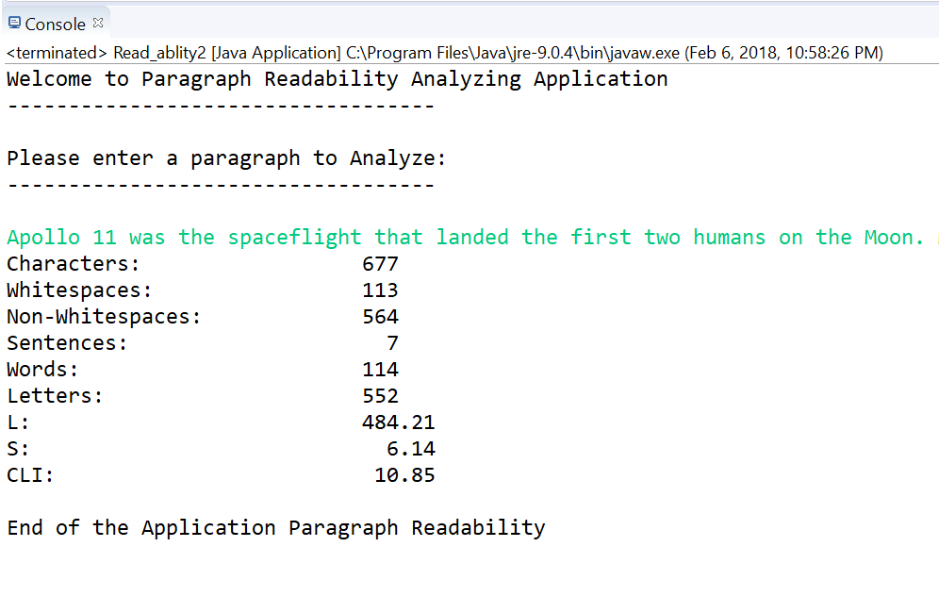

*]\*\**

* **Copying-and-pasting application code to a Word document**

1) From the program editor window, press **CTRL-A** and press **CTRL-C**.

2) From within the Word document, press **CTRL-V**.

** **Copying-and-pasting application output to a Word document**

1) From the Eclipse main screen, maximize the Console window.

2) From the Console window, press **ALT-PrintScreen**.

3) From within the Word document, press **CTRL-V**.